Frequently Asked Questions 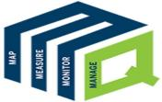
An EASY GUIDE to MQUAD

A mobile-based application specifically designed to cater to the requirements of the Development sector to map, measure, monitor and manage data efficiently.

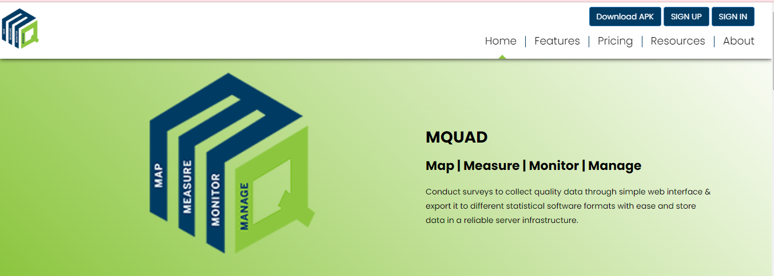

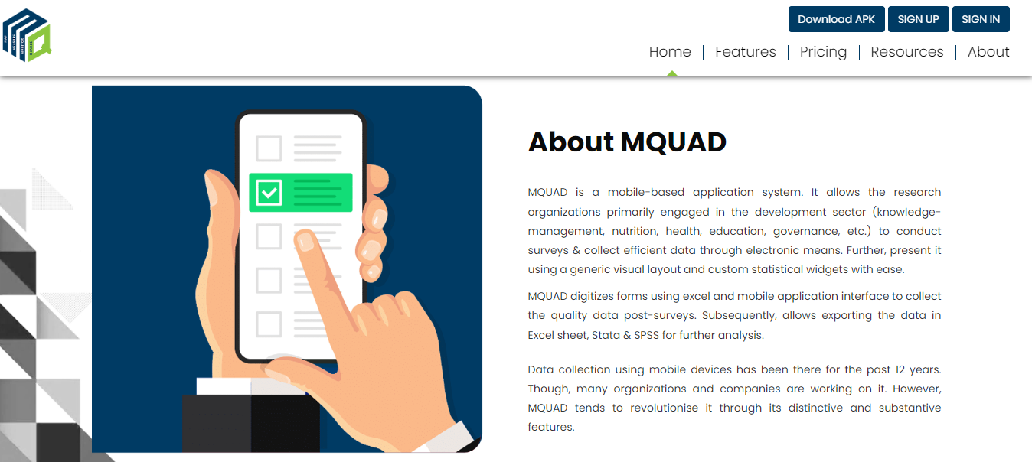

What are the features offered ?

Repository Services
MQUAD provides comprehensives solutions to store, exchange and access tools, questionnaires and collected data as part of MQUAD or otherwise.

• Question bank
• Tool archives.
• Data repository.

- Advanced Form Management

State of art functionalities allows user to create, manage and do several other things with menu driven options

• Excel and web-based form development.
• Multi-format look-up functionality.
• Inter-portability.

- Sampling Module

Implements alogorithm to draw samples without storing data

• Simple random sampling.
• Systematic random sampling.

- Data Quality Analytics

MQUAD provides a range of data quality parameters including time, GPS, keystroke, etc.

• Timestamp.
• Keystroke.
• Audio.
• Sleep time.
• Hint and error statistics.
• Others.

- User Friendly

No need for users to have advanced technical skills or programming knowledge, hence, user friendly.

• Menu driven.
• Easy to locate functions.
• Rich help files.
• Example excel forms.

- Data Export

MQUAD allows export of data into multiple formats.

• Excel.
• Stata.
• SPSS.
• JSON.

- Support Services

MQUAD has a system to support its users in a quick and transparent way.

• Response within 12 hours.
• Demo videos.
• MQUAD community.

- Do I need to pay for sign up?

- How can I get a demo of MQUAD?

The demo of MQUAD is defined on the demonstration section of home page . Here is a quick overview of the specific features of MQUAD that will enhance your understanding and experience in data collection, management, analysis and reporting.



- Who all can use MQUAD?

MQUAD has a wide variety of users. They use MQUAD in different ways to discover insights.

• Evaculator.
• Market Researchers.
• Psychologists.
• Health Researchers.
• Social Scientists.
• Students and Teachers.
• Policy Researchers.
• Sociologists.

- What are the subscription options available?

- Types of support available from MQUAD to deploy this in my organization.

MQUAD has a wide variety of features.

• Designed for groups and organizations with exceptional management.
• Technical.
• Security.
• End-user support needs.
- What is the maximum number of questions one can build in?

- What type of questions can be developed?

- What are the domains/topics on which validated questions are available?

- How does MQUAD help in data quality assurance?

- How does MQUAD work?

MQUAD work by Conducting surveys to collect quality data through simple web interface & export it to different statistical software formats with ease and store data in a reliable server infrastructure.

- Do I need to know programming to work with MQUAD?

No it is not compulsory : anyone can use it easily. MQUAD has a wide variety of users. They use MQUAD in different ways to discover insights.

- If I am not a survey expert, what support/resources does MQUAD provide?
MQUAD provides sufficient materials that help to conduct the survey.

• Help File.
• FAQ.
• Video Demonstration.
• sample Question.

- Can I try MQUAD before I take a subscription?

- Can MQUAD be used beyond survey data collection?

- Can I add a logo to the form?
You can add a logo when login MQUAD.

How to sign up for MQUAD ?

There is availability of membership to conduct interviews, visualize data and export it for further analysis.
You can become a member by subscribing to Basic, Standard or Advance membership plans.

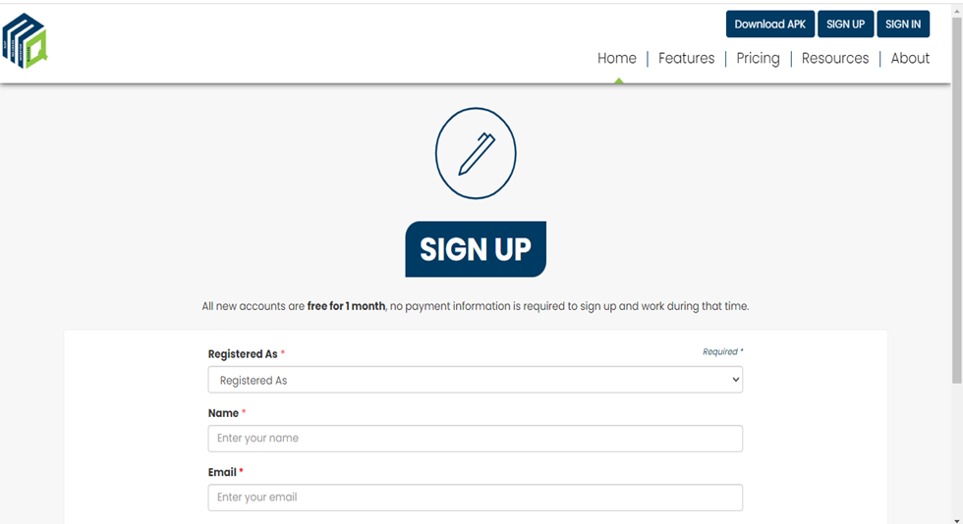

How to login to MQUAD ?
You can login with your username and password.

In case, you forget your password, you have an option to Reset it:

- Click Forgot Password
- Enter your email ID
- Tick the captcha
- Submit

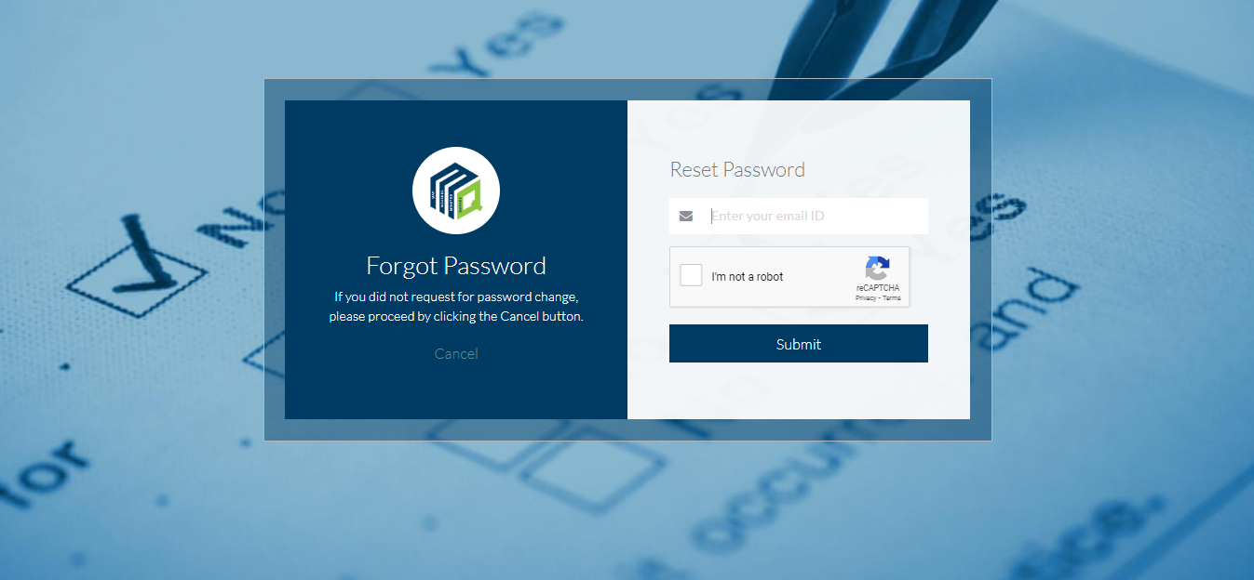
How to create a Form?

Once you login, you are on the Home page

To create a new form:

- Go to Form Builder, select New Form Builder
- Select the Information Area and the Client name.
- Fill up the form name b
- Click on Upload from File and select the excel form
- Click on the Save option to upload.

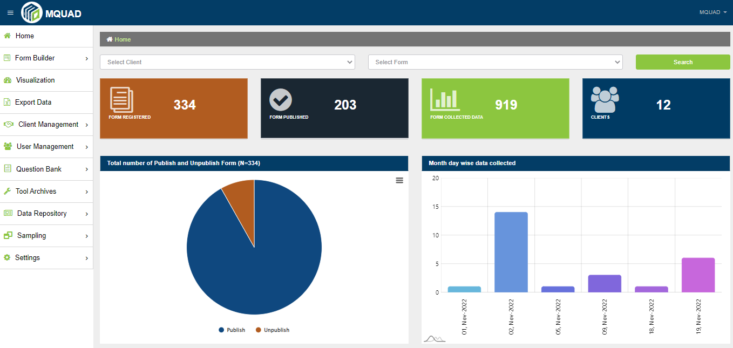
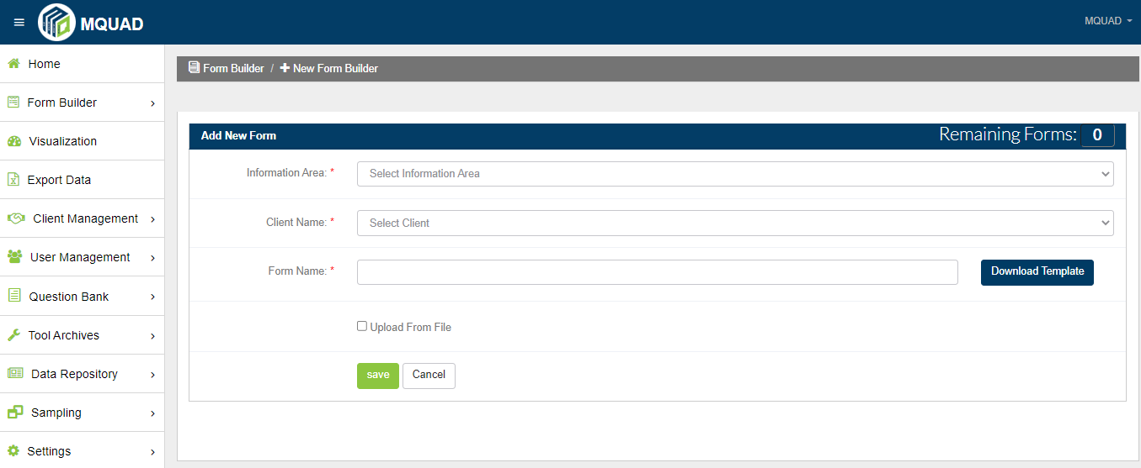

- How to validate a questionnaire Excel Sheet?

To validate a questionnaire Excel Sheet:

- Go to Form Builder, select Validate Excel Form
- Click on Upload Questionnaire and select the Excel File
- Click on the Verify option to upload

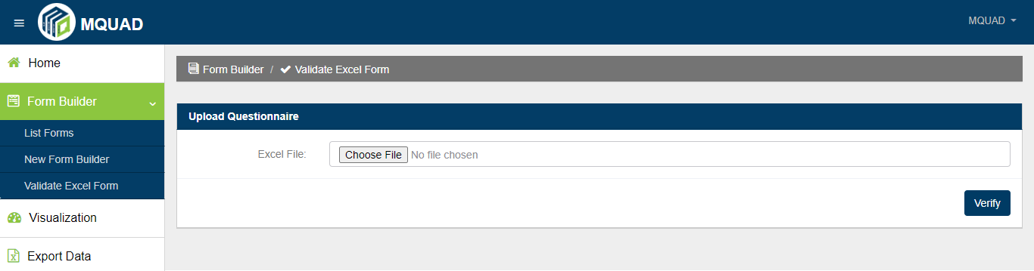

- How to publish a form?

- After creating a Form , go to Form Builder, click on Form List.
- Then, go to the Manage Section and click on the Publish button to Publish.
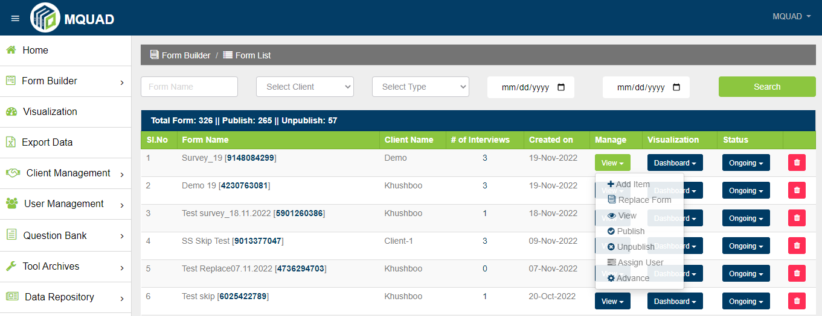

- How to assign a form to the user?

To assign a user:
- select the user
- click on the Submit button to Assign

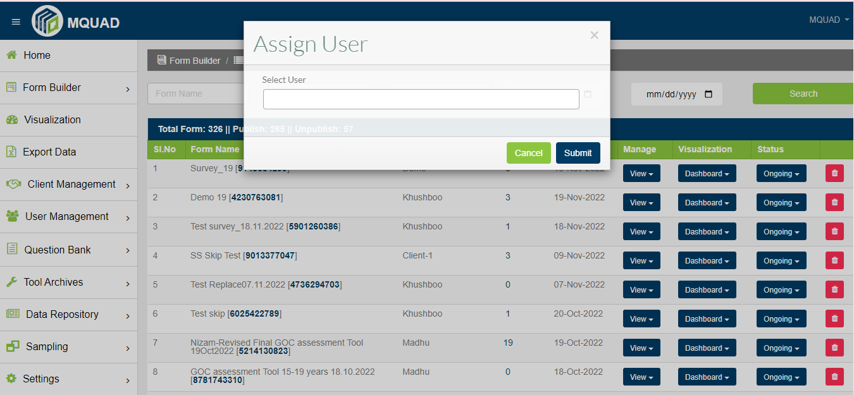

- How to visualize data in MQUAD?

- Data API
- Custom Dashboard

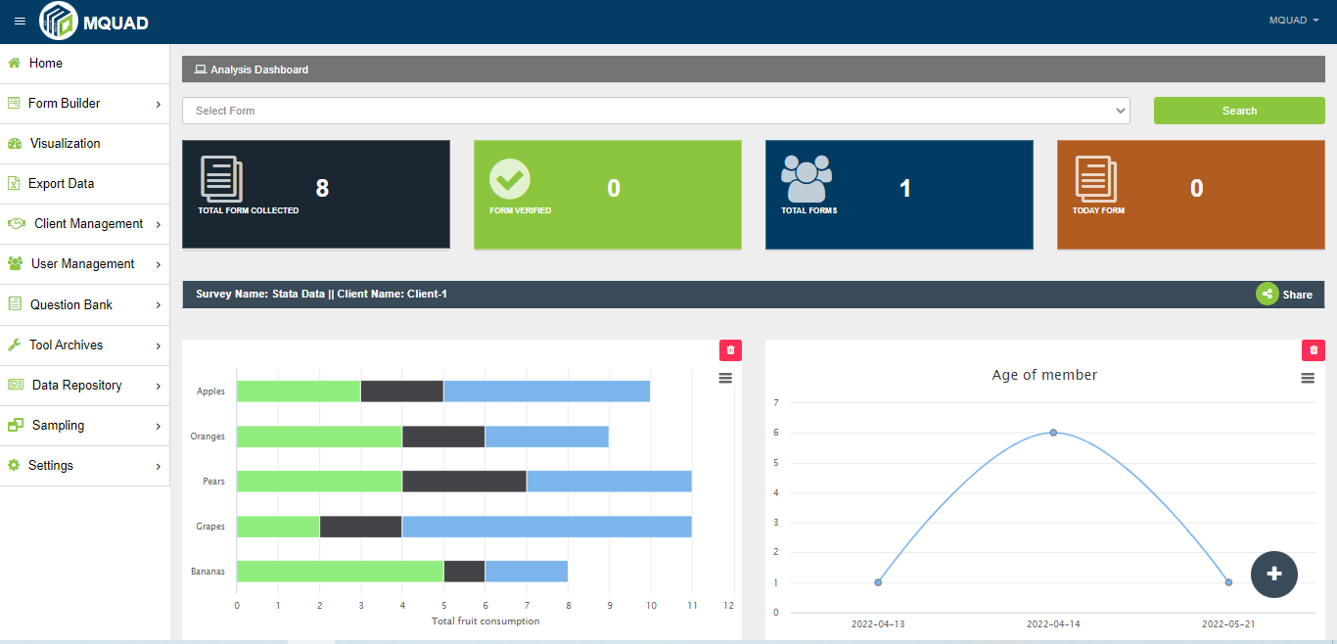

- How to export data in MQUAD and what type of data can be exported?

Select the Export Data option.
You can export data with multiple formats:
- Excel with Label
- Excel without Label
- STATA
- SPSS
- JSON
- PARADATA

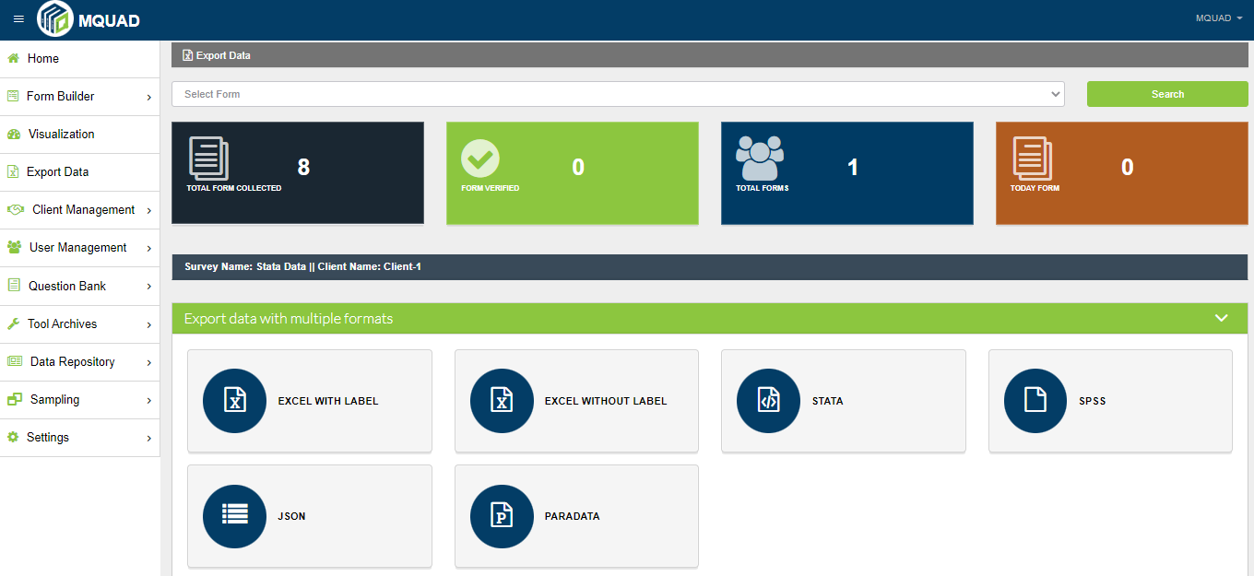

- What is a Advanced Manage Option in MQUAD

You can access the Advanced Manage option:
- Go to Form Builder
- Click List Form
- Click on the Dashboard

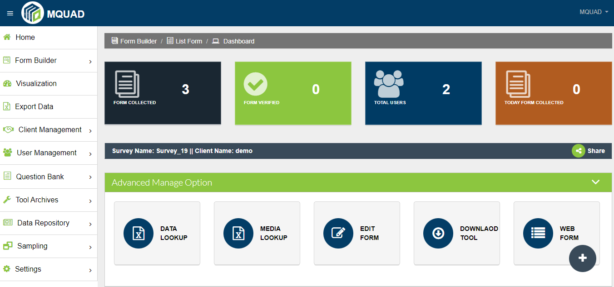

- How to Edit a Questionnaire from the Web ?

To edit a Questionnaire:
- Go to Form Builder
- Click on List Form
- Click on Edit Question

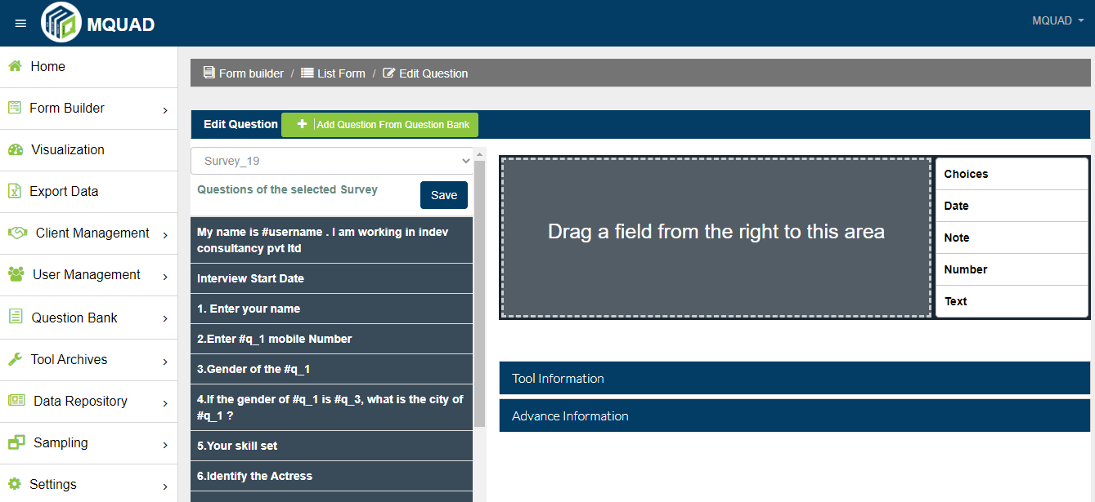

- How to start surveys via the web ?

- Select the language and start the interview.

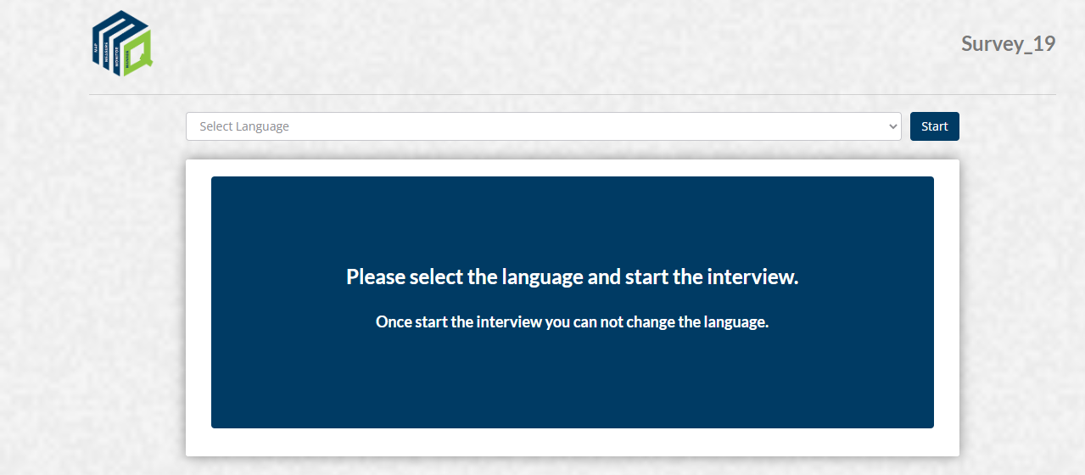

- How to add and list clients?

To Add Client:
- Go to Client Management
- Select Add Client
- Fill up the details
- Submit

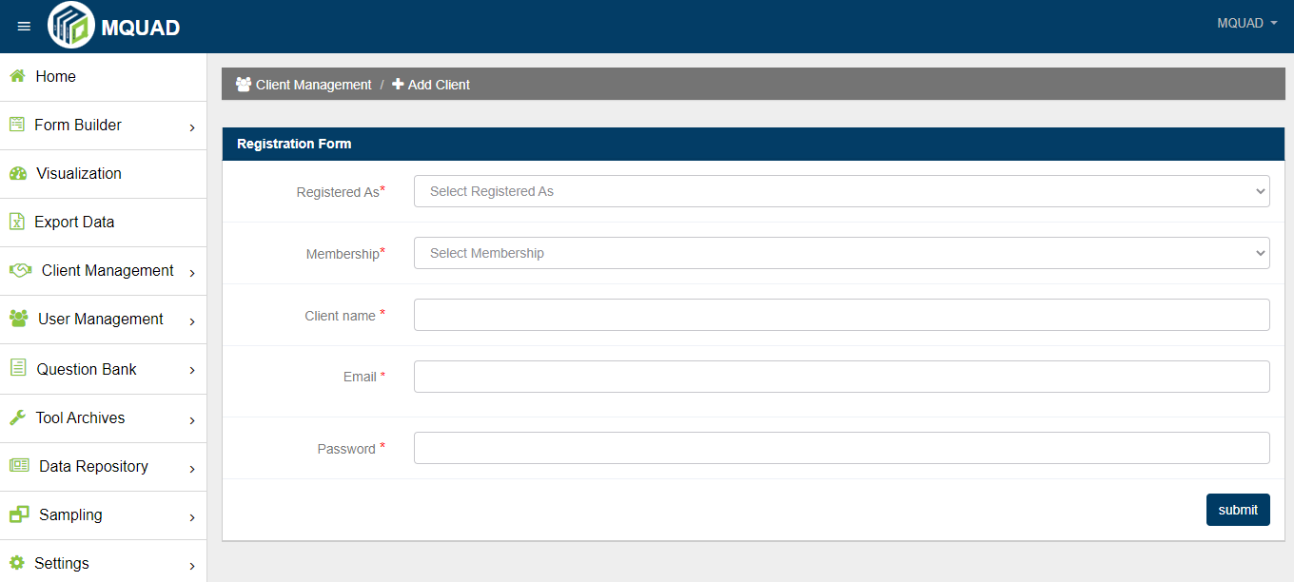

To List clients:

- Go to Client Management
- Click List Clients

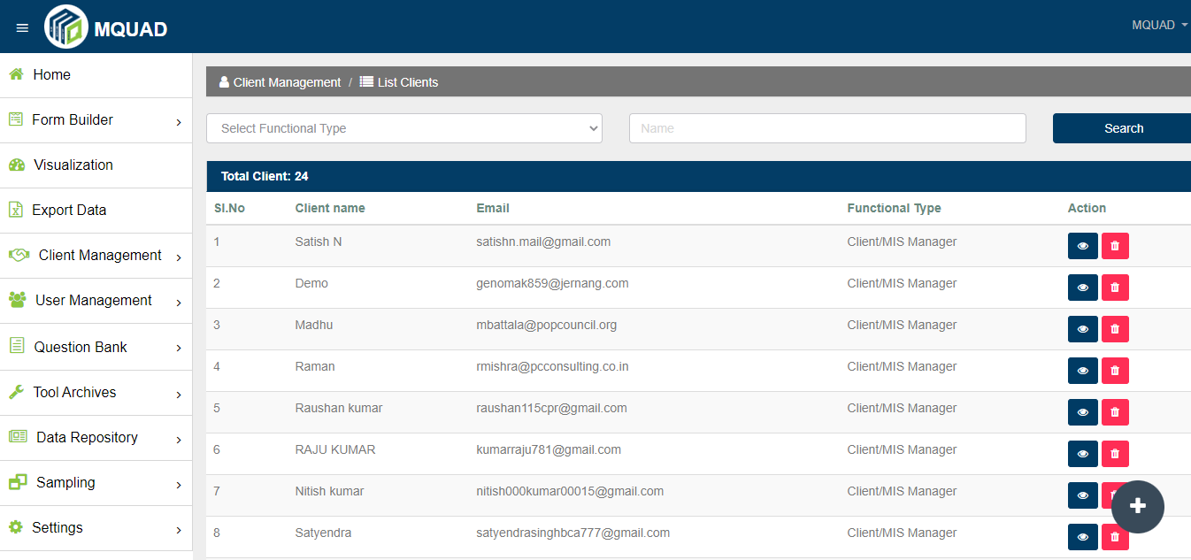

- How to add and list users?

To Add User:
- Select User Management
- Click Add User
- Fill up the details

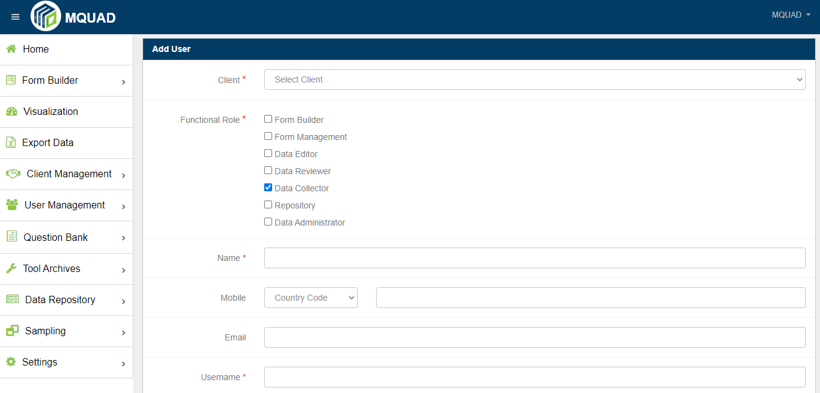

To List Users:
- Select User Management
- Click List UsersList

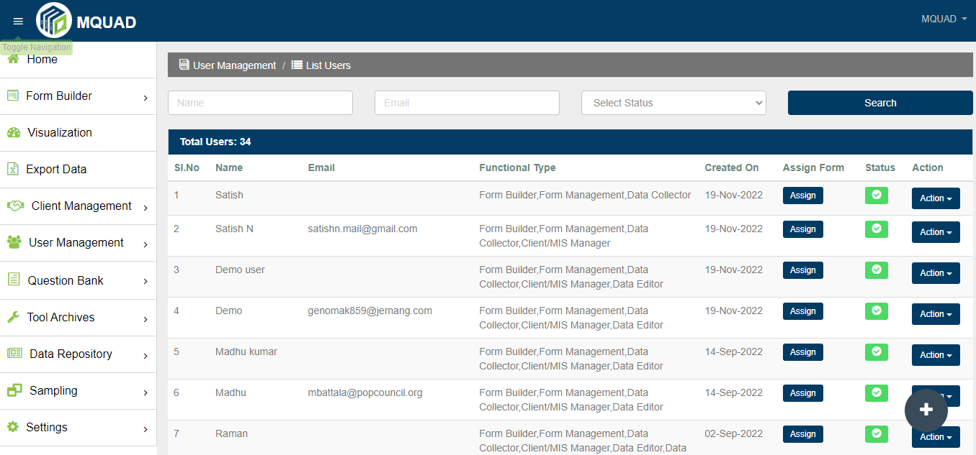

- How to add and show questions?

To Add Questions:
- Select Question Bank
- Click Add Question
- Fill up the details
- Submit

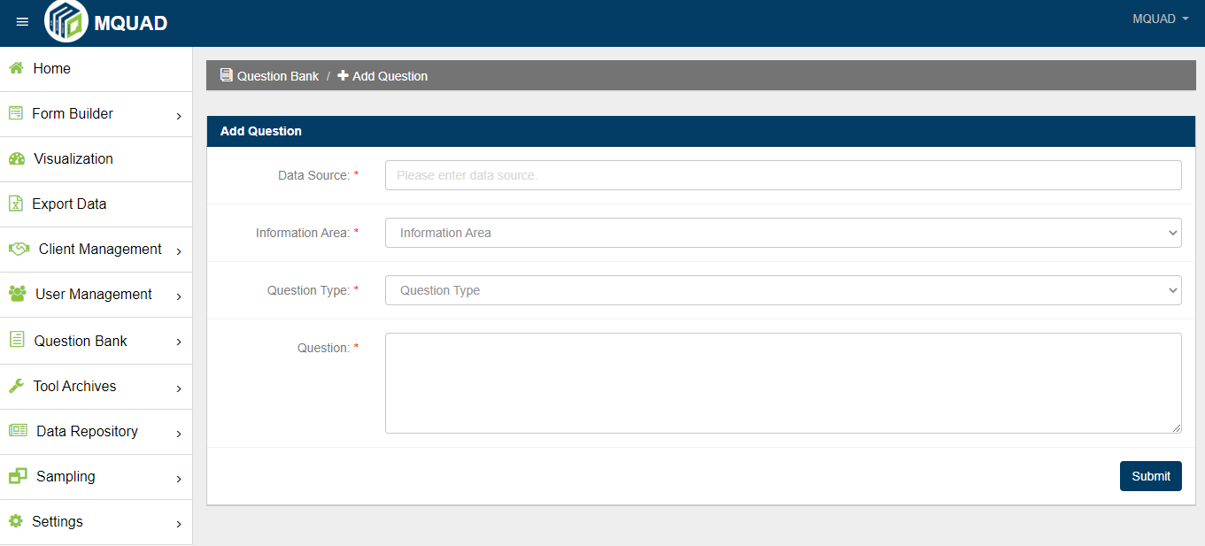

To Show Questions:
- Select Question Bank
- Click Show Questions

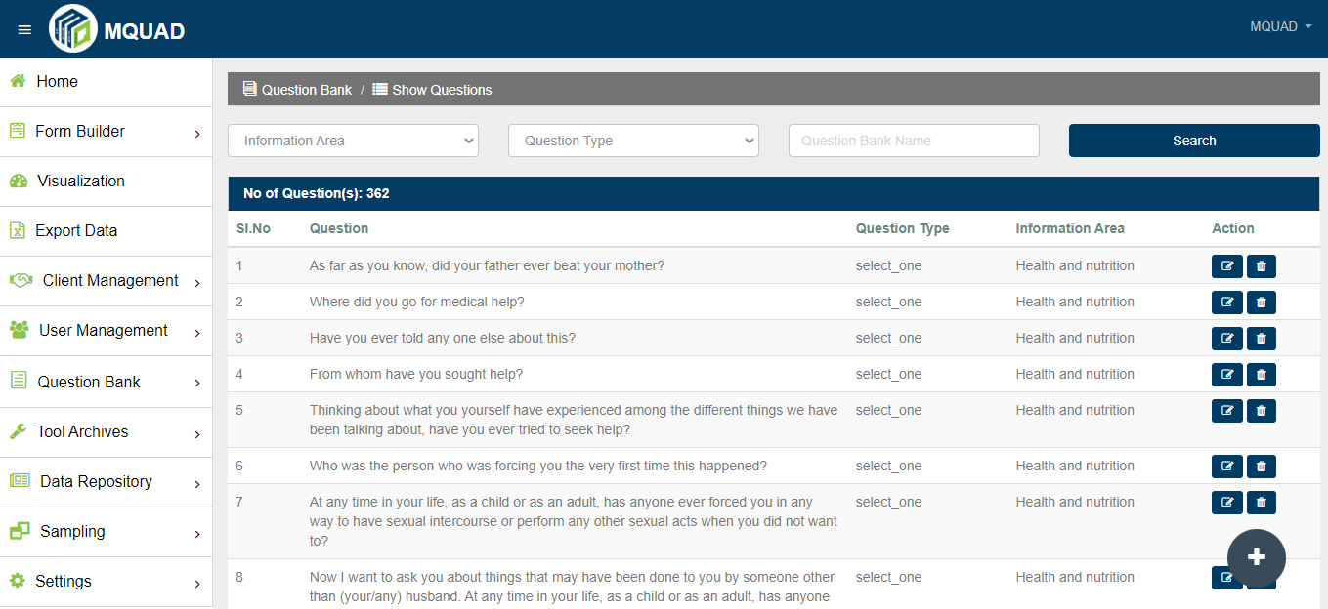

- How to use Tool Archives?

To Add Tool:

- Select Tool Archives
- Click Add Tool
- Fill up the details

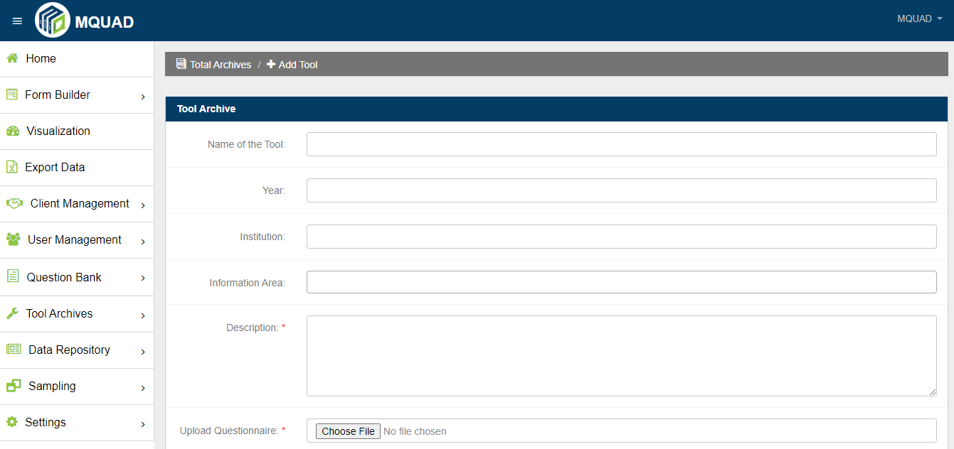

To Show Tools:
- Select Tool Archives
- Click Show Tools

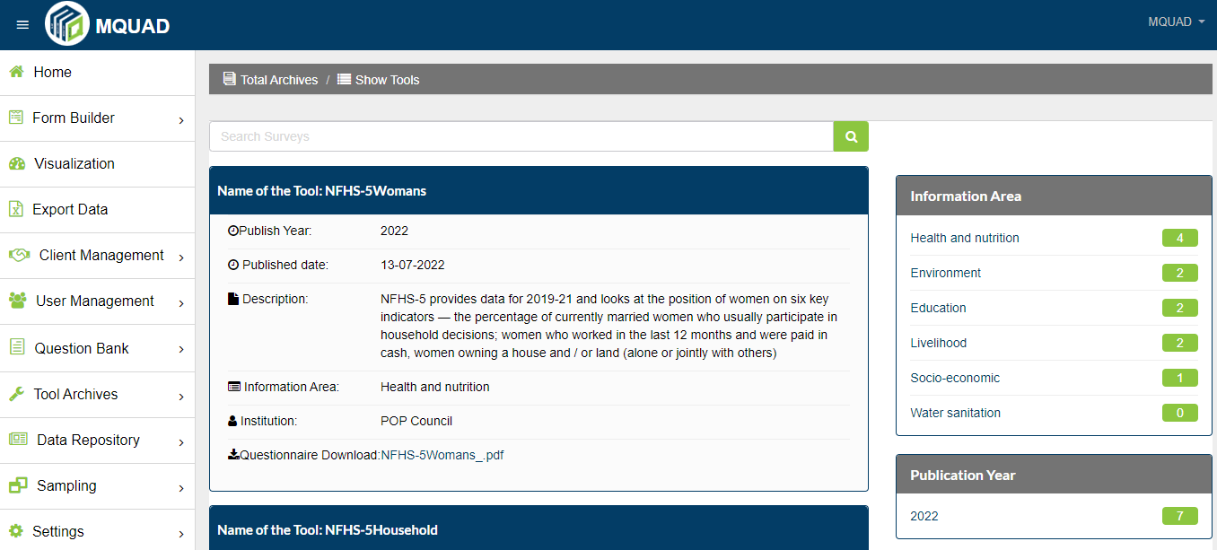

- How is the Dataset added and seen ?

To Add Dataset:

- Select Data Repository
- Click Add Dataset
- Fill up the details

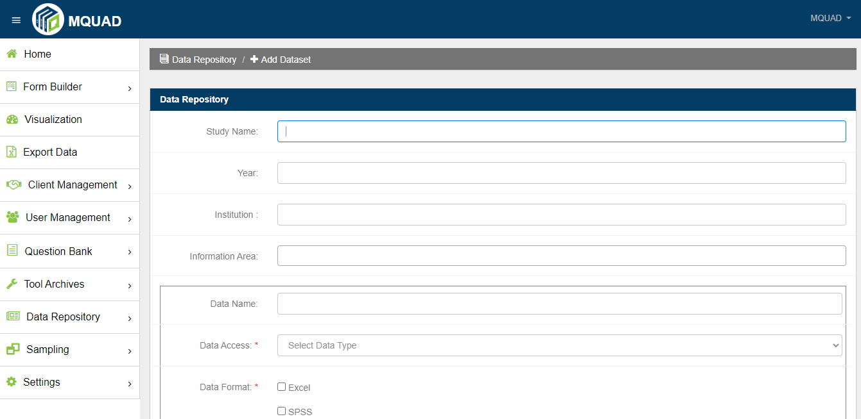

To Show Dataset:

- Select Data Repository
- Click Show Dataset

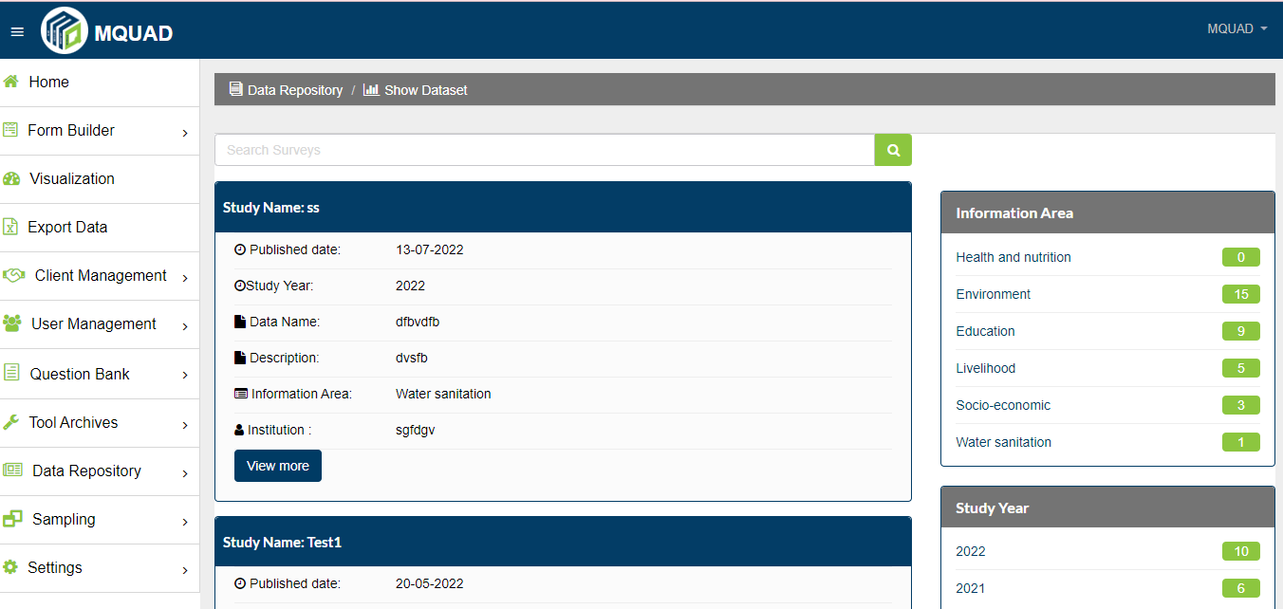

- How to do Sampling ?

To do Sampling:

- Select Sampling
- Click Simple Random/ Systematic Random Sampling
- Upload File
- Fill up the details
- Submit

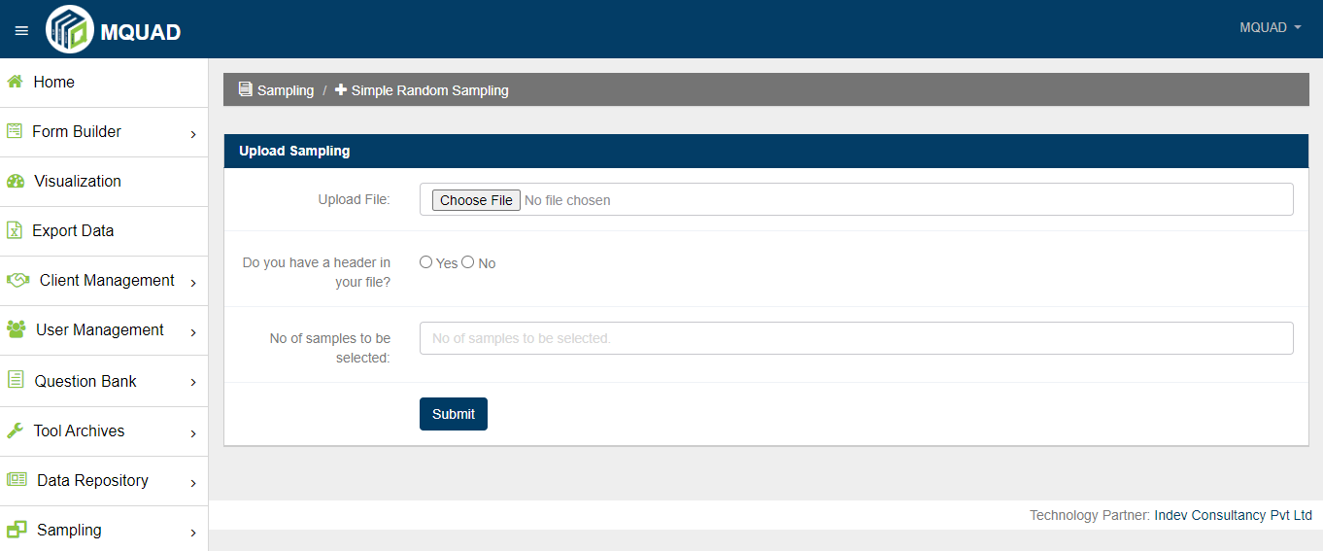

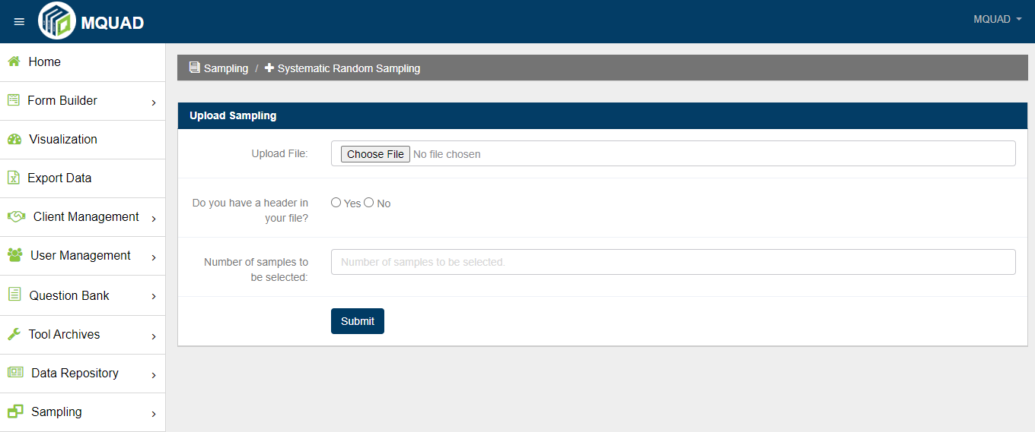

- How to locate an Information Area ?

To locate Information Area:

- Select Setting
- Click Information Area

